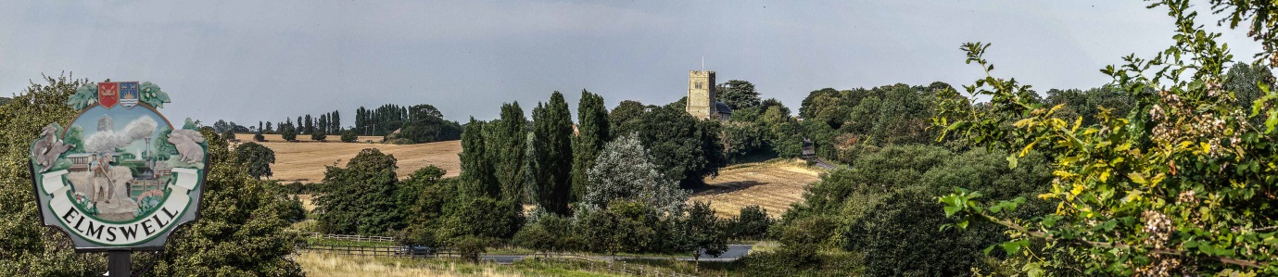

Elmswell Neighbourhood Plan
MINUTES
of a Steering Group meeting held on
1st July 2014 at The Blackbourne
Present: Philip Blissett, Julie Cole, Peter Dow, Peter Edmonds, Terry Garner, Peter Goodridge,
Sarah Mansel (Ch.), Fred Pallett, Shaun Pratt,
1. Apologies for absence were received from Marian Abbott, Gillian Benjamin,
Mary Feeney and Ann Richards
2. The Minutes of the last meeting, held on 11th June, were approved as a true record.
3. There was a thoroughgoing line-by-line review of the CAS draft questionnaire with proposed amendments noted in full and wide ranging discussion. PD undertook to draft a revised document for circulation and individual review towards a second group exercise at the next meeting.
4. Peter G and Julie reported on substantive progress with social networking so that the website is up and running, although needing some further substance, and the Newsletter is to carry details of QR codes etc.
5. 5.1 Peter Dow reported that adequate feedback from SCC suggested that Mary Feeney’s analysis of the County’s school intake process was sound and that no further enquires required in this regard.
5.2 Peter Dow confirmed that the Village Recorder was pursuing appropriate map documents to be included in the Plan.
5.3 Peter Dow confirmed that MARPA have agreed to help with freight statistics and will report back.
5.4 Harrow Estates traffic statistics were noted as being extremely comprehensive and best left as available for reference.
5.5 School Travel plan statistics were left pending in Mary Feeney’s absence.
6. It was agreed that a protocol for emails should be on the next agenda.
7. It was agreed that the next meeting should be scheduled for Wednesday 23rd July at Blackbourne, beginning at 7.30.
8. The meeting closed at 9.45.

Peter Dow

